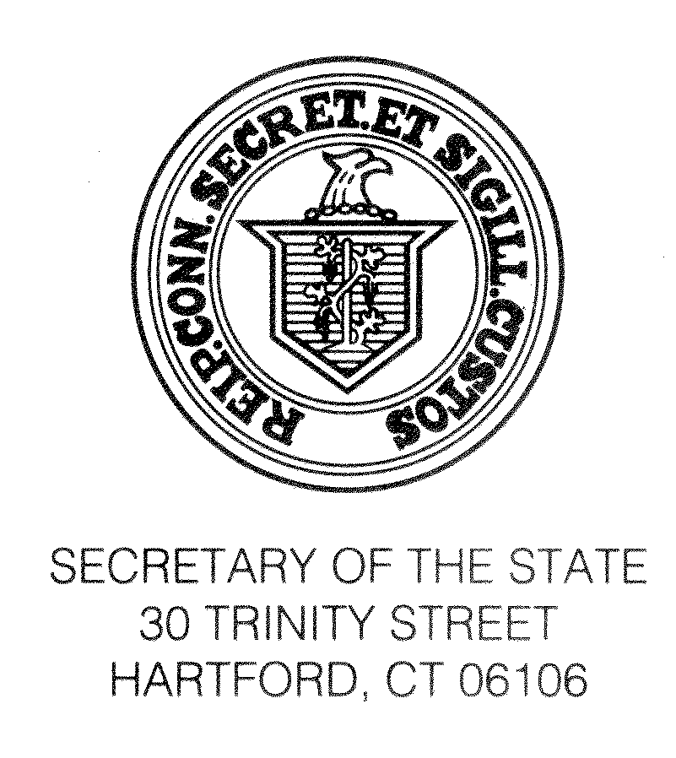
TO: All Registrars of Voters
RE: Annual Fall Conference
WHEN: Thursday, September 20 and Friday, September 21, 2018
WHERE: The Crowne Plaza, Danbury CT

It’s hard to believe that summer is behind us and that autumn is here. I am writing to encourage your participation in the upcoming Registrars of Voters Conference. The Conference will provide an excellent opportunity for Registrars from all over the state to come together and share ideas, strategies and best practices.

I encourage you to take advantage of this opportunity to spend time with our staff and to take part in what promises to be a very productive conference. This instruction is critical to ensuring that local election officials are up-to-date on new developments, including cybersecurity concerns, and have the tools necessary to effectively carry out their duties. The upcoming conference will greatly assist you in fulfilling your duties as Registrars.

Under the provisions of §9-6 of the General Statutes, each Registrar of Voters, or in the absence of the Registrar, the Deputy Registrar, who attends the conference shall be compensated by the municipality which they represent at the rate of $35.00 per day, “plus mileage to and from such conference at the rate determined by the municipality, but not less than twenty cents per mile.”

I am looking forward to meeting with you all at the conference on Secretary of the State Day, Friday September 21. I am well aware of the challenges we all face, certainly for my staff but particularly for you as election administrators on the front lines of democracy. The Deputy Secretary Scott Bates and I have visited towns throughout the state to see firsthand what we can do to help you during this election season.

I am most grateful to the President of the Registrars of Voters Association of Connecticut, Sue Larsen, her convention committee and to my staff for their hard work in preparing for what I know will be a wonderful conference.

Sincerely,

Denise W. Merrill
Denise W. Merrill
Secretary of the State

