
_______________________________________________________________________________________

TO: All Registrars of Voters

FROM: Denise W. Merrill
Secretary of the State

DATE: April 15, 2019

RE: Annual Spring Conference
April 15 - 17, 2019
Red Lion Hotel, Cromwell, CT

It’s time for us to come together again to share ideas and to take part in training that will help each of us to better carry out our duties as election officials. We learn as much from these conferences as you do, and we enjoy the opportunity to meet colleagues we usually only communicate with via email or phone. The Spring Registrars of Voters Conference will be held at the Red Lion Hotel in Cromwell from April 15- April 17, 2019. Secretary of the State Day is Wednesday, April 17.

This year we will continue to focus on election security and integrity as we prepare for the 2020 election. Our office will be joined by officials with the Department of Homeland Security, and the Election Infrastructure Information Sharing and Analysis Center (EI-ISAC).

I encourage you to take advantage of this great training opportunity. As many of you know, Section 9-6 of the General Statutes provides that each registrar of voters, or in the absence of a registrar, the deputy registrar attending the conference shall be compensated by the municipality which they represent at the rate of $35.00 per day, “plus mileage to and from such conference at the rate determined by the municipality, but not less than twenty cents per mile.”

We know that most of you have now completed the program and satisfied your requirements for certification as registrars pursuant to Sec. 9-192a of the Connecticut General Statutes. I know you join me in thanking the Certification Advisory Committee for all their work in developing this comprehensive model curriculum for the training and accreditation of registrars: Anne-Marie Mastroianni, John Visi, Carol Hurley, Barbara Brenneman, Staff Attorney Lew Button, and SEEC Attorney Kevin Ahern.

The consistently high turnout at these conferences demonstrates how crucial training is and how effective it can be to come together as a group of elections officials. I thank Sue Larsen, President of the Registrars of Voters Association of Connecticut, her conference committee, and my staff for all they have done to prepare for this conference.

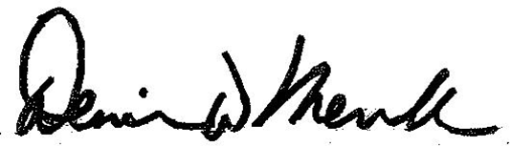
Sincerely,

Denise W. Merrill
Secretary of the State

